**Depth to Water Table – Indices & More**

Created by Fisher Ankney, [fisherankney@gmail.com](mailto:fisherankney@gmail.com), February 14, 2017

Last updated 2/27/2017

***Description –***

Evaluate depth to water table estimates against cottonwood tree measurements, including normalized ring width indices, height, vigor, dbh, and age.

***Sources* –**

Depth to water table values are measured and estimated from the auger hole cross sections conducted on each of the four Bijou Creek study areas. Measurements were taken on August 8th (MaClennon), August 9th (Hutto), October 8th (Bradbury), and October 9th (Bijou Basin), 2016. Cross sections created from these measurements can be found in Bijou Creek / subsurface. A map pinpointing the exact location of the reference auger holes can be found at Bijou Creek / maps / Bijou Creek.kmz.

Tree measurements, including: height, vigor, and dbh, were taken as the trees were cored in the summer of 2016. Establishment years are calculated in the folder Bijou Creek / analysis / tree rings /. Tree ring RCS chronologies and indices are calculated in the folder Bijou Creek / analysis / standardized RCS indices. These calculations are the basis for any study folder that has the prefix “indices –“.

*Notes – Master.xls*

*D2w_source.xls (all pages)*

*Bijou Creek.kmz*

*BB Cross section.pdf*

*B3 Cross section.pdf*

*B9 Cross section.pdf*

*B12 Cross section.pdf*

***Scripts –***

*d2w_density_script.R*

*d2w_indices_script.R*

*d2w_dbh_script.R*

*d2w_height_script.R*

*d2w_vigor_script.R*

*d2w_establish_script.R*

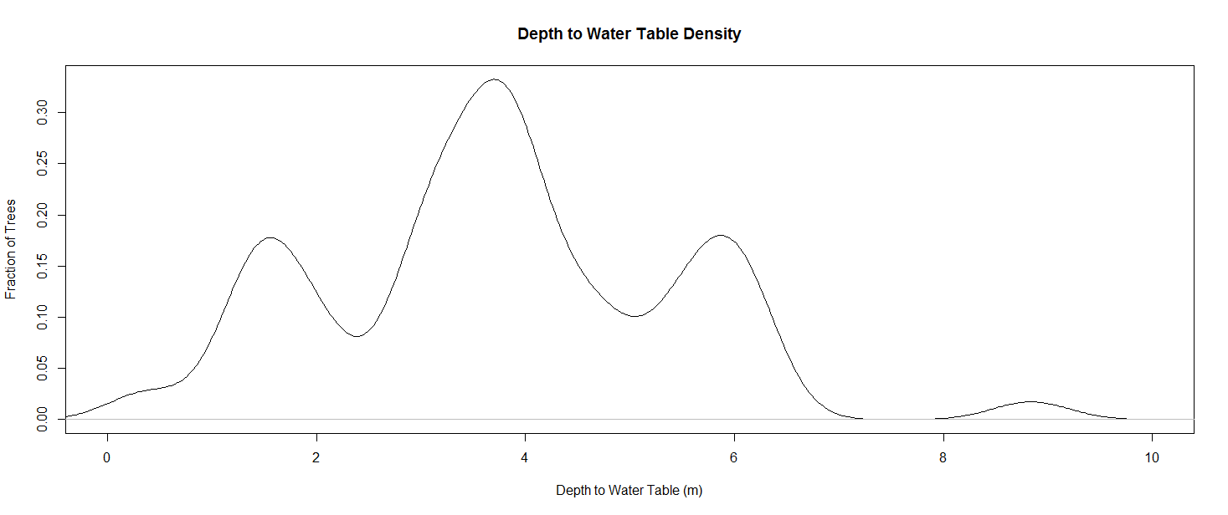***Results -***

